Name :
Hafsa Waseem
Roll no :
Su92-bssem-s24-014
Subject :
Mad (lab)
Submitted to :
Sir Muhammad Abdullah
Task no 4 :
Question no 1 :
Main dart code :
import 'package:flutter/material.dart';
import 'splashscreen.dart';
import 'login_screen.dart';
import 'signup_screen.dart';
void main() {
runApp(const MyApp());
}
class MyApp extends StatelessWidget {
const MyApp({super.key});
@override
Widget build(BuildContext context) {
return MaterialApp(
debugShowCheckedModeBanner: false,
title: 'Flutter Assignment',
theme: ThemeData(primarySwatch: Colors.blue),
home: const SplashScreen(),
routes: {
'/login': (context) => LoginScreen(),
'/signup': (context) =>SignupScreen(),
},
);
}
}

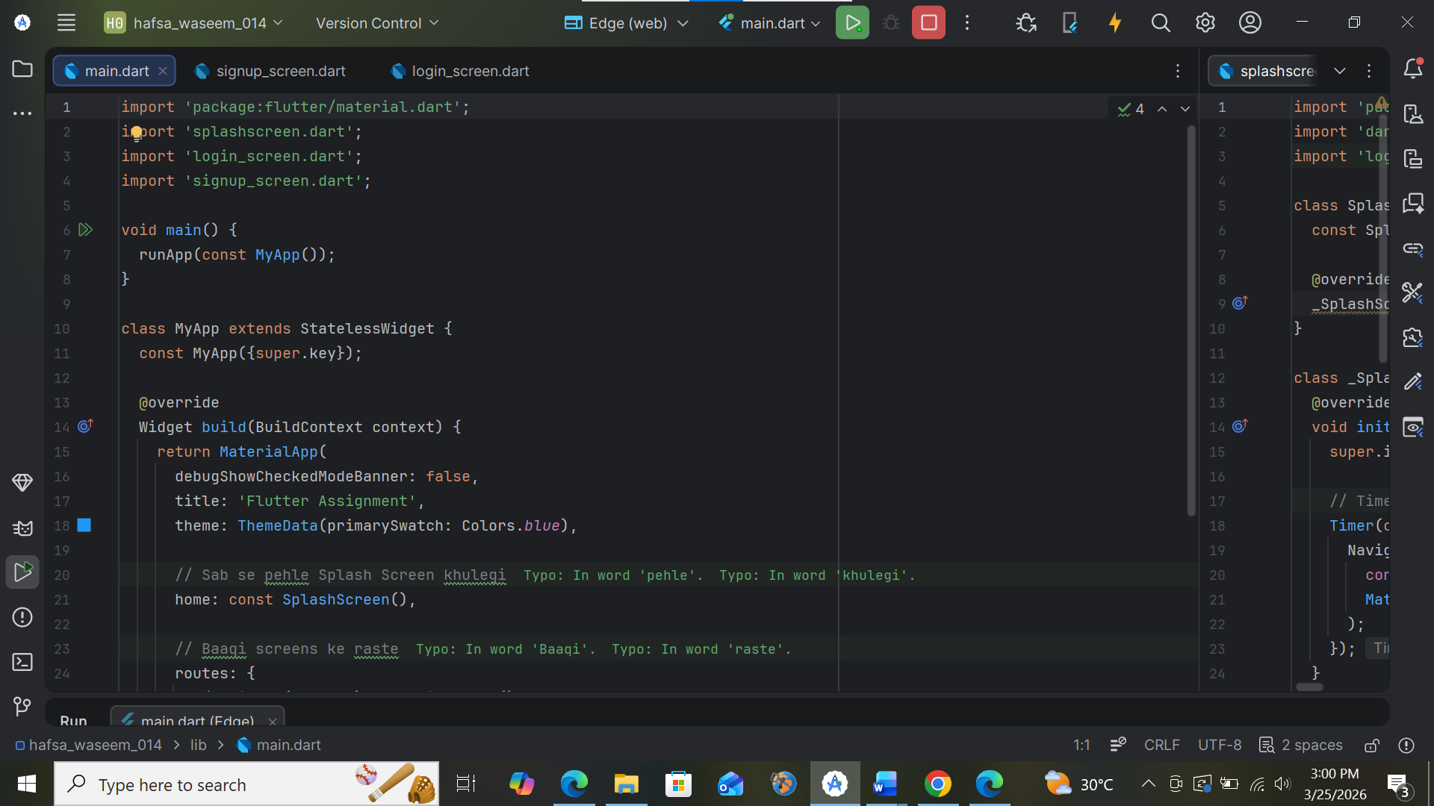
Splash screen :
Code :
import 'package:flutter/material.dart';
import 'dart:async';
import 'login_screen.dart';
class SplashScreen extends StatefulWidget {
const SplashScreen({super.key});
@override
_SplashScreenState createState() => _SplashScreenState();
}
class _SplashScreenState extends State<SplashScreen> {
@override
void initState() {
super.initState();
Timer(const Duration(seconds: 5), () {
Navigator.pushReplacement(
context,
MaterialPageRoute(builder: (context) => LoginScreen()),
);
});
}
@override
Widget build(BuildContext context) {
return const Scaffold(
backgroundColor: Colors.blue,
body: Center(
child: Column(
mainAxisAlignment: MainAxisAlignment.center,
children: [
Icon(Icons.flash_on, size: 100, color: Colors.white),
SizedBox(height: 20),
Text(
"My Application",
style: TextStyle(
color: Colors.white,
fontSize: 24,
fontWeight: FontWeight.bold
),
),
],
),
),
);
}
}
output :

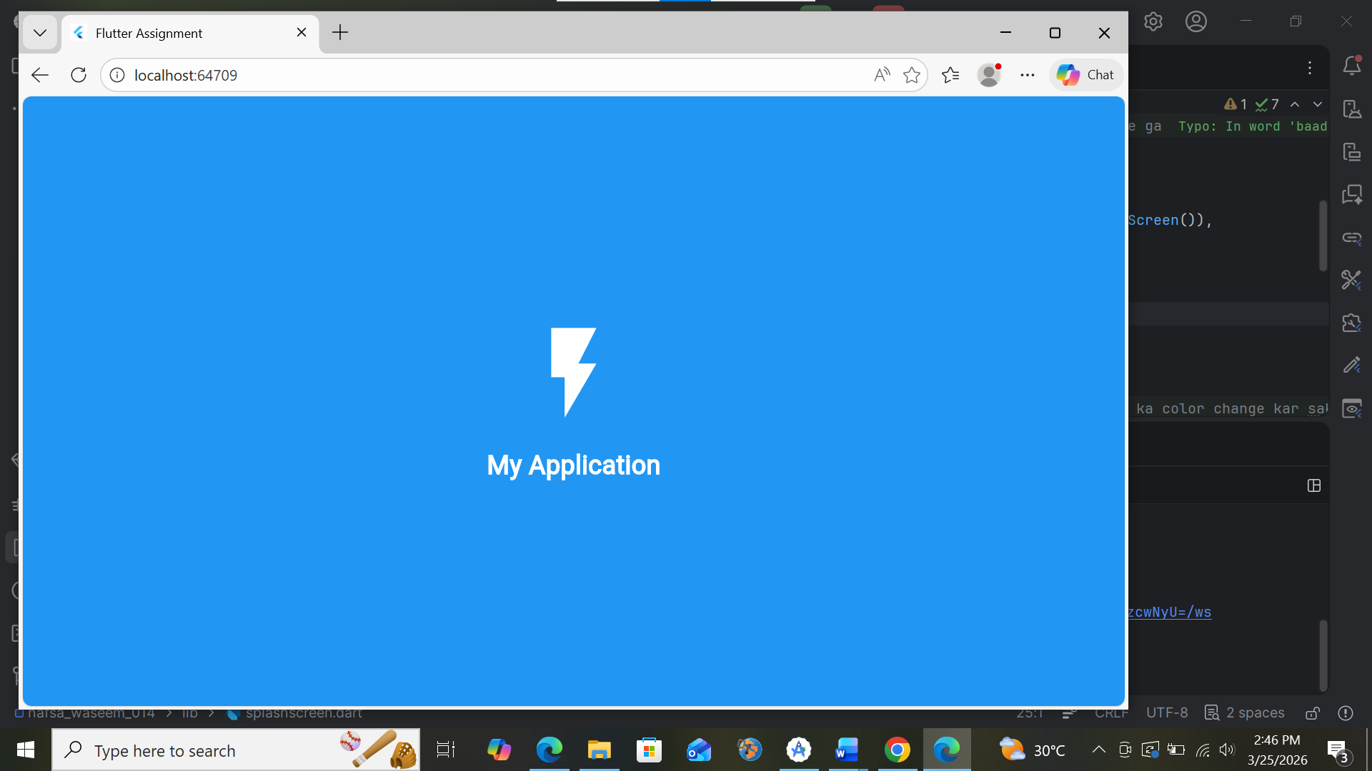
Code output :
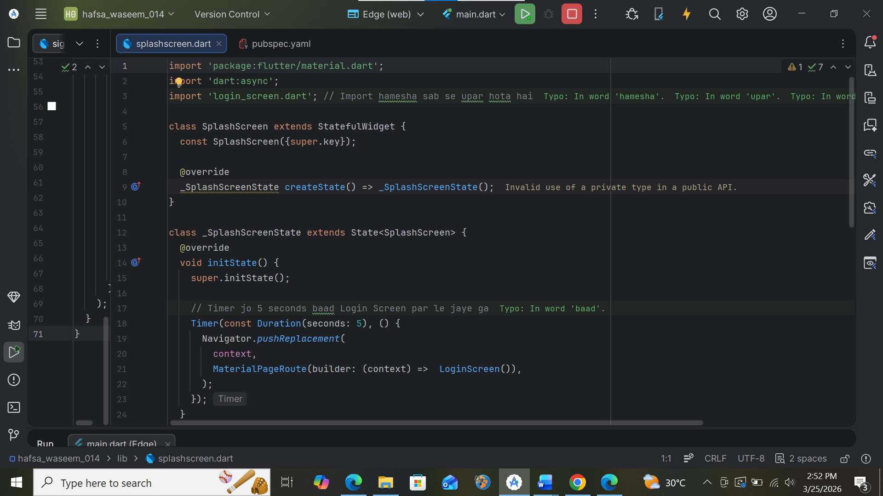

Login screen:
import 'package:flutter/material.dart';
class LoginScreen extends StatelessWidget {
const LoginScreen({super.key});
@override
Widget build(BuildContext context) {
return Scaffold(
backgroundColor: Colors.white,
body: Center(
child: SingleChildScrollView(
child: Padding(
padding: const EdgeInsets.symmetric(horizontal: 30),
child: Column(
mainAxisAlignment: MainAxisAlignment.center,
children: [
const Icon(Icons.lock_outline, size: 80, color: Colors.blue),
const SizedBox(height: 20),
const Text(
"Welcome Back",
style: TextStyle(fontSize: 28, fontWeight: FontWeight.bold, color: Colors.blue),
),
const SizedBox(height: 10),
const Text("Login to your account", style: TextStyle(color: Colors.grey)),
const SizedBox(height: 40),
const TextField(
decoration: InputDecoration(
labelText: "Email",
prefixIcon: Icon(Icons.email_outlined),
border: OutlineInputBorder(),
),
),
const SizedBox(height: 20),
const TextField(
obscureText: true,
decoration: InputDecoration(
labelText: "Password",
prefixIcon: Icon(Icons.lock_outline),
border: OutlineInputBorder(),
),
),
const SizedBox(height: 10),
Align(
alignment: Alignment.centerRight,
child: TextButton(
onPressed: () {},
child: const Text("Forgot Password?"),
),
),
const SizedBox(height: 20),
SizedBox(
width: double.infinity,
height: 55,
child: ElevatedButton(
style: ElevatedButton.styleFrom(
backgroundColor: Colors.blue,
shape: RoundedRectangleBorder(borderRadius: BorderRadius.circular(10)),
),
onPressed: () {
print("Login Pressed");
},
child: const Text(
"LOGIN",
style: TextStyle(color: Colors.white, fontSize: 18, fontWeight: FontWeight.bold),
),
),
),
const SizedBox(height: 20),
Row(
mainAxisAlignment: MainAxisAlignment.center,
children: [
const Text("Don't have an account?"),
TextButton(
onPressed: () {
Navigator.pushNamed(context, '/signup');
},
child: const Text(
"Sign Up",
style: TextStyle(fontWeight: FontWeight.bold, color: Colors.blue),
),
),
],
),
],
),
),
),
),
);
}
}
output :
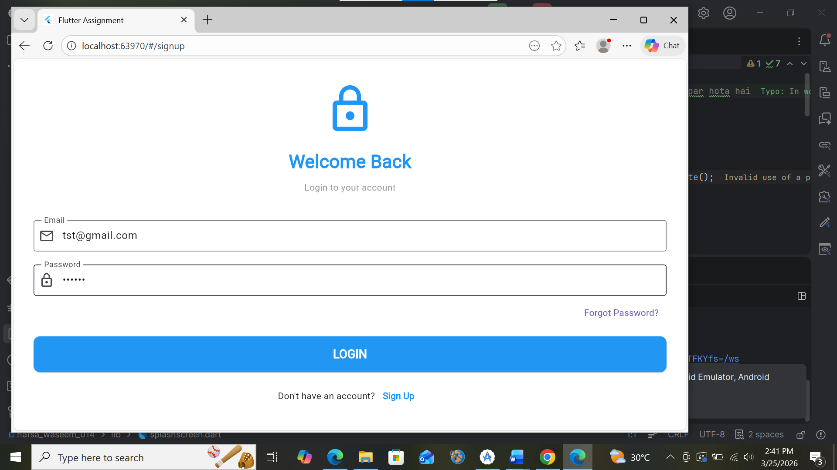
Code output :
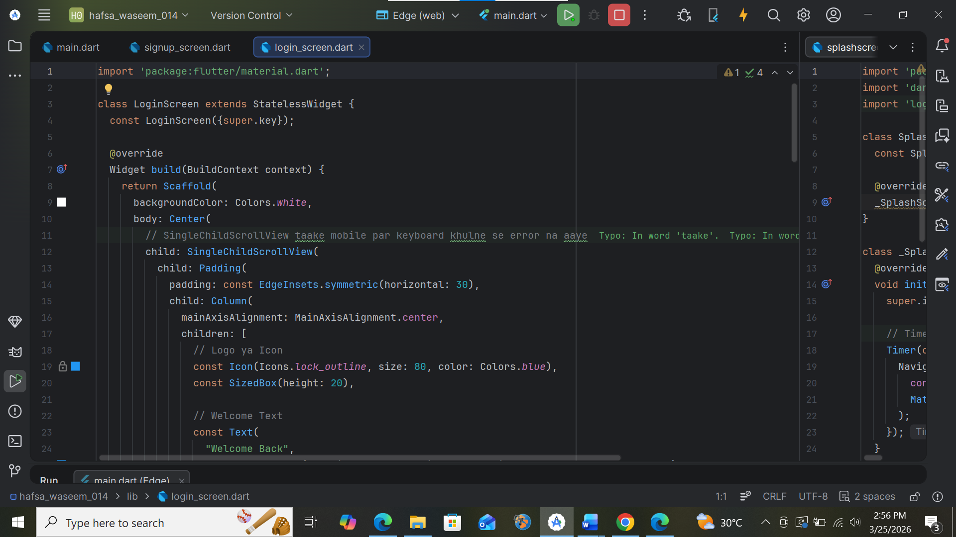

Signup screen :
Code :
import 'package:flutter/material.dart';
class SignupScreen extends StatelessWidget {
const SignupScreen({super.key});
@override
Widget build(BuildContext context) {
return Scaffold(
backgroundColor: Colors.white,
body: Center(
child: SingleChildScrollView(
child: Padding(
padding: const EdgeInsets.symmetric(horizontal: 30),
child: Column(
mainAxisAlignment: MainAxisAlignment.center,
children: [
const Text(
"Create Account",
style: TextStyle(fontSize: 28, fontWeight: FontWeight.bold, color: Colors.blue),
),
const SizedBox(height: 30),
const TextField(
decoration: InputDecoration(
labelText: "Full Name",
prefixIcon: Icon(Icons.person),
border: OutlineInputBorder(),
),
),
const SizedBox(height: 20),
const TextField(
decoration: InputDecoration(
labelText: "Email",
prefixIcon: Icon(Icons.email),
border: OutlineInputBorder(),
),
),
const SizedBox(height: 20),
const TextField(
obscureText: true,
decoration: InputDecoration(
labelText: "Password",
prefixIcon: Icon(Icons.lock),
border: OutlineInputBorder(),
),
),
const SizedBox(height: 30),
SizedBox(
width: double.infinity,
height: 50,
child: ElevatedButton(
style: ElevatedButton.styleFrom(backgroundColor: Colors.blue),
onPressed: () {
Navigator.pop(context);
},
child: const Text("SIGN UP", style: TextStyle(color: Colors.white, fontSize: 18)),
),
),
const SizedBox(height: 10),
TextButton(
onPressed: () => Navigator.pop(context),
child: const Text("Already have an account? Login"),
),
],
),
),
),
),
);
}
}
output:
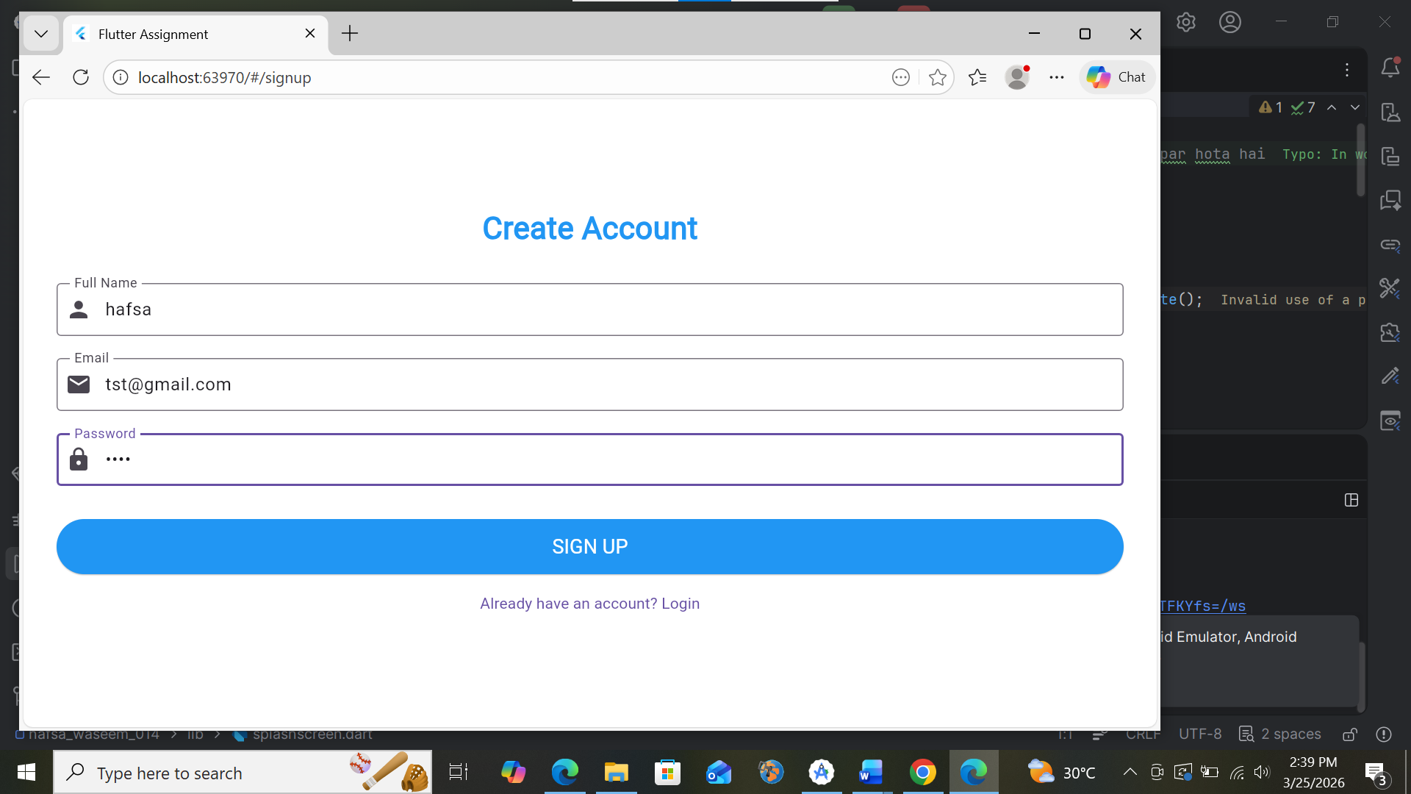
Code output :
